Input & Camera v. 0.3

Overview
This is Layer A, the layer between the player and the simulation. It owns how a device becomes an input struct, and what the camera does.
Camera is in this document rather than in a presentation document because it is a control surface, not a visual one. In an arcade driving game the camera does most of the work of communicating speed — field of view, pullback, shake and settling tell the player how fast they are going far more effectively than the number of metres per second they are actually travelling. A boost that does not move the camera does not feel like a boost, regardless of what the Drive Model did to the velocity. That makes camera behaviour a feel mechanic tuned alongside input, not a polish pass applied afterwards.
There is no assist system. An earlier draft carried steering assist, wall nudge, auto-accelerate, drift entry assist and an assist tier structure. None of it is built. Accessibility for a younger audience is handled instead by a single generous, tunable value — the drift release window width, which lives in the Drift & Boost Economy document. That is one number a designer can widen, rather than a subsystem with settings UI, and it can be revisited after playtesting if the game proves too hard.
The platform is PC only. Keyboard and gamepad. There is no touch scheme, no virtual stick, and no tilt or gyroscope input anywhere in this document.
The foundation ships no heads-up display. Speed and boost state are communicated by the camera; charge state is communicated on the robot itself, per Drift & Boost. Between them the foundation needs no screen furniture at all. Per-game HUD — a lap counter, a timer, a score, a minimap — belongs to Layer H and is each mini-game’s own concern.

Design Goals
- The input struct is the only thing the simulation sees. Every device and every control scheme resolves into the same small struct before the simulation runs. Nothing downstream knows or cares whether the player is on a keyboard or a gamepad.
- The same five inputs exist in every mini-game. Accelerate, brake, steer, hop, boost. A sixth input is a foundation-level change, not a per-game one.
- Camera communicates speed, contact and boost state without any heads-up display.
- Camera never takes control away. No forced cinematic angles during gameplay, no camera that fights the player’s steering, no automatic look-at that overrides where the player is trying to look.
- Input resolution is deterministic and tick-aligned. The struct is built before the simulation runs and is what gets replicated.
- Camera is smooth regardless of tick rate. It runs on the render frame, reads simulation state, and never writes it.

Core Mechanics

Input resolution
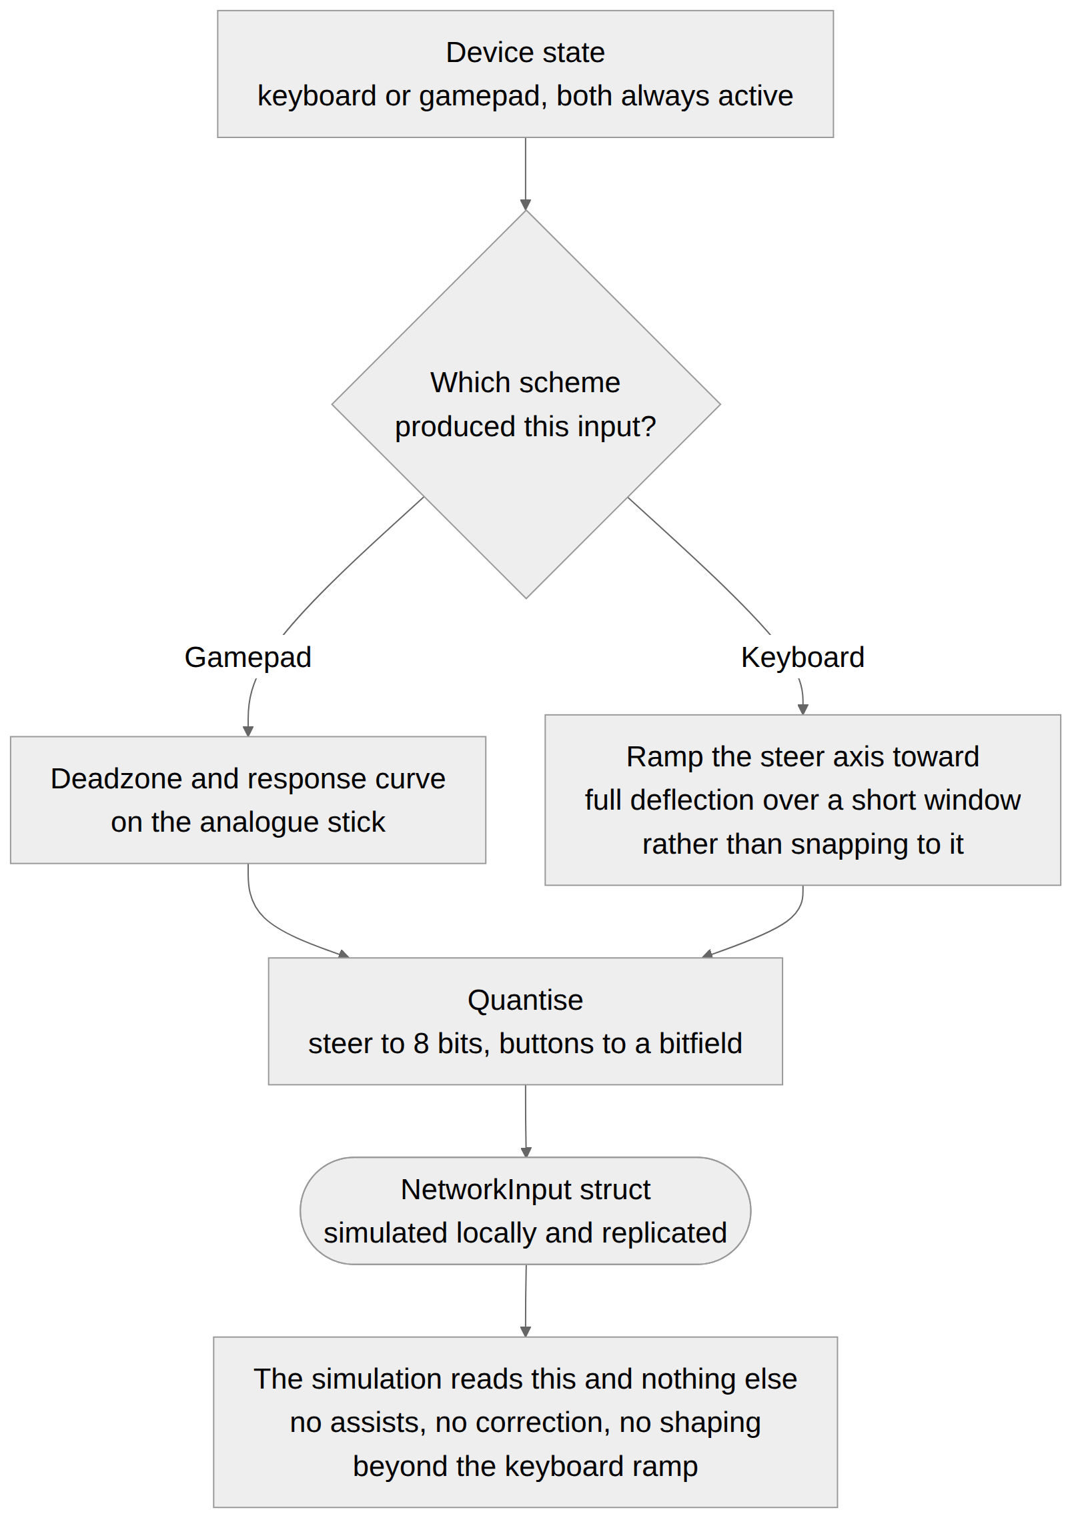
Raw device state becomes a NetworkInput in a short fixed sequence, and the output is identical in shape regardless of device.
Step | What happens
1. Sample device | Read the active control scheme’s raw state
2. Apply deadzone and curve | Analogue steering only, for gamepad. Deadzone removes stick drift; the response curve shapes fine control near centre
3. Resolve digital steering | Keyboard only. A held key ramps the steer axis toward full deflection over key_steer_ramp_ticks rather than snapping to it
4. Quantise | Steer axis to 8 bits, buttons to a bitfield
5. Emit | The NetworkInput struct for this tick, consumed by the simulation and sent to the authority
On keyboard steering. A keyboard gives a binary left or right, and feeding that straight in as full deflection makes the robot twitch. Ramping the axis over a short window gives a keyboard player something close to analogue control without any assist logic — it is a property of how a digital key becomes an analogue value, not a correction applied to the player’s intent. Releasing the key ramps back to centre over the same window. This is the one piece of input shaping in the document and it exists because keyboard is a first-class scheme on a PC-only platform.

Control schemes
Scheme | Accelerate | Brake / Reverse | Steer | Hop | Boost
Keyboard | W or Up | S or Down | A/D or Left/Right | Space | Left Shift
Gamepad | Right trigger | Left trigger | Left stick | A / Cross | Right shoulder
Hop and boost are separate controls on both schemes. They could share one — a press before the drift starts is a hop, a press during the release window is a boost, and the two are never both meaningful at the same instant. On a PC there is no shortage of keys or buttons, so the sharing is unnecessary, and separate controls are clearer to teach and clearer to read in a tutorial prompt. The Crash Team Racing drift loop is preserved exactly: press hop to enter, hold the slide, release, press boost inside the window.
Both schemes are always active. A player can switch between keyboard and gamepad mid-match without configuration; the scheme switches on the next tick and the struct shape is unchanged.

Camera
One camera model, parameterised through the handling profile. No per-game camera code.
Element | Behaviour
Base | Chase camera at authored distance, height and pitch, following the chassis with a spring
Follow model | Follows the chassis’s velocity direction rather than its facing. During a drift the chassis points into the slide while the camera stays behind the direction of travel
Speed-linked field of view | FOV widens with speed ratio, including above 1. A chained chassis has a visibly wider view than a chassis at nominal top speed. This is the primary speed cue
Speed-linked pullback | Camera distance increases with speed ratio, alongside FOV
Boost response | On a boost, a fast FOV punch and pullback, settling over the boost’s duration. Each chain link punches again, slightly stronger
Drift response | Slight lateral offset toward the outside of the drift and a small roll, exaggerating the slide
Contact response | Shake scaled by impulse. Distinct shake character for landing a hit versus receiving one
Spin-out | Camera holds its heading rather than following the chassis’s rotation. A camera that spins with the robot is nauseating and unreadable; a camera that holds still while the robot spins in front of it is legible and funny
Airborne | Slight pitch down to keep the landing point visible
Slope | No dedicated behaviour. The chassis pitches with the terrain and the spring follows, which reads correctly without a special case
Collision with geometry | Camera pulls in when geometry intrudes, never clips through. Recovers smoothly
On following velocity rather than facing. This is the most important camera decision in the document. A camera locked behind the chassis’s nose swings wildly during a drift, because the nose is pointing somewhere the chassis is not going. Following the velocity direction keeps the view stable and shows the player the drift from outside it, which is both more readable and the thing that makes drifting look good.
No corner look-ahead. A camera that biases toward the route ahead helps on blind corners and is the behaviour most likely to feel like the camera fighting the player. It is not built. Blind corners are treated as a level design concern, and a racing mini-game that needs route awareness will carry its own minimap as part of its per-game HUD.
Arena camera. The same model with a shorter distance, a higher pitch and reduced speed-linked response, since arena speeds are lower and situational awareness matters more than a sense of velocity. Delivered as camera values in the Arena profile preset rather than as a second camera.

Data Structures
InputConfig {
KeyboardBindings
GamepadBindings
SteerDeadzone // gamepad only
SteerResponseCurve // gamepad only
KeySteerRampTicks // keyboard only
}
CameraConfig { // lives in the handling profile ScriptableObject
BaseDistance, BaseHeight, BasePitch
FollowSpring, FollowDamping
FovBase, FovAtSpeedRatioOne, FovPerOverspeedUnit
PullbackPerSpeedRatio
BoostPunchMagnitude, BoostPunchTicks
ChainPunchScaling, ChainPunchCap
DriftLateralOffset, DriftRoll
ShakePerImpulse, ShakeMaxMagnitude
SpinoutHoldHeading // bool, default true
AirbornePitchBias
GeometryPullInSpeed
MotionScale // single multiplier on every dynamic term
}

Key Methods
// Input, per tick, before the simulation runs
ResolveInput(deviceState, inputConfig, previousSteerAxis) returns NetworkInput
ApplyDeadzoneAndCurve(rawSteer, config) returns float // gamepad
ResolveKeyboardSteer(keys, previousAxis, config) returns float // keyboard ramp
// Camera, per render frame, not per tick
UpdateCamera(chassis, driftState, recoveryState, cameraConfig, deltaTime)
ApplyBoostPunch(magnitude)
ApplyContactShake(impulse, wasAggressor)
ResolveGeometryIntrusion()
// Queries
GetActiveScheme() returns Scheme
On camera running per render frame. Camera is presentation and must be smooth at whatever frame rate the machine delivers, independent of the simulation tick rate. It reads simulation state and never writes it, so it sits outside the determinism contract entirely. This is the one place in the foundation where reading render-frame delta time is correct.
On the keyboard steer ramp and determinism. The ramp accumulates across ticks, which makes the previous steer axis part of the input resolution state. It is applied before the struct is built, so what gets replicated is the already-ramped value and no peer needs to know anything about how it was produced. The accumulating value is local input state, not simulation state, and needs no replication.

Balance Considerations

Tuning parameters
Parameter | Provisional | Range | Purpose
steer_deadzone | 0.12 | 0.05 to 0.25 | Gamepad stick drift rejection
steer_response_curve | Slight ease near centre | — | Fine control at small deflections
key_steer_ramp_ticks | 9 (~0.15 s) | 4 to 20 | Keyboard axis ramp to full deflection
fov_base | 62 deg | 55 to 75 | At rest
fov_at_speed_ratio_one | 78 deg | 70 to 92 | At nominal top speed
fov_per_overspeed_unit | +14 deg per 1.0 over | 5 to 25 | The chaining cue. The most satisfying number in the document
pullback_per_speed_ratio | 1.2 m | 0.5 to 2.5 | Distance increase with speed
boost_punch_magnitude | 6 deg FOV, 0.5 m distance | — | Instant response on boost
boost_punch_ticks | 10 | 5 to 20 | Punch settle time
chain_punch_scaling | 1.15× per link | 1.0 to 1.4 | Escalation per chain link
chain_punch_cap | 4 links | 3 to 8 | Ceiling on visual escalation, not on the chain itself
drift_lateral_offset | 0.6 m | 0.2 to 1.5 | Camera slide toward the outside of a drift
drift_roll | 3 deg | 0 to 8 | Camera roll during a drift
shake_max_magnitude | Capped deliberately low | — | Shake reads as impact; too much reads as a broken camera
airborne_pitch_bias | 8 deg down | 3 to 18 | Keeps the landing visible
motion_scale | 1.0 | 0 to 1 | Single multiplier scaling every dynamic camera term

The relationships that matter
FOV response against motion comfort. A wide FOV swing is the strongest speed cue available and also the most likely to cause discomfort. The recommended approach is to tune the FOV response for maximum feel first, then verify with a comfort pass, and expose motion_scale as a single reduced-camera-motion option that scales FOV, pullback, shake and roll together. One option that scales everything is far more usable than five separate sliders, and it is the only player-facing setting this document asks for.
Chain punch cap against long chains. The chain itself is uncapped, per Drift & Boost. The visual escalation is capped at chain_punch_cap links, because an unbounded camera punch becomes uncomfortable long before a skilled player stops chaining. Audio escalation carries the cue beyond that point.

What cannot be settled here
Whether key_steer_ramp_ticks at 9 is right depends on max_yaw_rate and steer_response from the Drive Model, and all three should be tuned together against a prototype rather than independently. Too short and keyboard steering is twitchy; too long and it feels unresponsive.

Edge Cases
- A player switches control scheme mid-match — a gamepad is connected while playing on keyboard. The scheme switches on the next tick, the struct shape is unchanged, and nothing downstream notices.
- A player holds both left and right on the keyboard. Resolves to zero steer axis, ramping from wherever the axis currently is rather than snapping.
- A player releases the steering key. The axis ramps back to centre over key_steer_ramp_ticks rather than snapping, so a key release does not jerk the robot straight.
- Camera geometry intrusion during a spin-out. Pull-in behaviour applies as normal while the camera holds its heading. The two behaviours are independent.
- Boost punch fires while the camera is already pulled in against geometry. The punch is applied to the target, and the intrusion resolver clamps the actual position. The FOV component still applies fully, so the boost still reads even in a tunnel.
- A player with reduced motion enabled reaches a long chain. The chain still escalates, at the scaled magnitude. Audio escalation is unaffected and carries the cue.
- A chassis reverses at speed. The camera follows velocity direction, which would put it in front of the robot. Reverse is excluded from the velocity-follow term below a threshold speed, so the camera stays behind the robot while reversing rather than swinging around.
- A player boosts and is hit on the same tick. Both camera responses apply. Shake is additive on top of the punch, subject to shake_max_magnitude.
- Frame rate drops well below tick rate. Camera interpolates from the latest simulation state and remains smooth relative to what it is given. It does not attempt to compensate for the simulation.

Open Decisions
None outstanding. The assist system, control schemes, tilt input, corner look-ahead and heads-up display have all been ruled on and are recorded in the System Overview’s decision table.
One item is flagged for the tuning pass rather than as a decision: if playtesting shows the game is too hard for a younger audience, the first and probably only lever to reach for is window_ticks in the Drift & Boost Economy document, not anything in this one. Nothing in the input layer should be modified to make the game easier — that is what the window width is for.

Integration Notes
- Requires: Vehicle Drive Model for speed ratio, grounded state and slip angle. Drift & Boost Economy for drift phase, charge stage, chain count and boost state. Collision & Recovery for impulse magnitude and spin-out state. Handling Profiles & Surfaces, which carries the camera configuration per preset.
- Integrates with: Vehicle Network Sync, which receives the input struct this document produces.
- Affects: Every mini-game’s control layout, since none of them define their own.
- Does not cover: Any heads-up display, minimap or screen furniture. Menu and lobby input, which belongs to the Matchmaking & Lobby System. Haptics, which should probably exist and are not specified here. Audio, beyond noting that camera and audio escalation carry the same cues.
- Follow up: Tune key_steer_ramp_ticks together with max_yaw_rate and steer_response on the first prototype. Re-baseline the FOV response after a motion comfort pass.

Success Metrics
- Keyboard steering feels controlled rather than twitchy at top speed
- A player can switch between keyboard and gamepad mid-match with no configuration and no visible change
- A player can tell they are boosting, and roughly how long a chain is, with no heads-up display and the sound off
- The camera never obscures the landing point on a jump
- A spin-out does not spin the camera
- The camera never swings in front of the robot while reversing
- No screen furniture of any kind is present in a foundation build

Implementation Checklist
A milestone breakdown of everything specified in this document, so that a developer can confirm nothing was missed. Milestones are ordered so that each one is testable before the next begins. An item marked [D] is a decision or confirmation rather than code.

M1 — Input resolution
☐ Single NetworkInput struct produced regardless of device
☐ Gamepad deadzone and response curve on the analogue stick
☐ Keyboard steer ramp toward full deflection over key_steer_ramp_ticks
☐ Release ramps back to centre over the same window
☐ Both left and right held resolves to zero, ramping rather than snapping
☐ Steer quantised to 8 bits, buttons to a bitfield
☐ Ramp state is local input state and needs no replication
☐ No assist logic of any kind — no auto-accelerate, steering assist, wall nudge or drift entry assist

M2 — Control schemes
☐ Keyboard bindings for all five inputs
☐ Gamepad bindings for all five inputs
☐ Hop and boost on separate controls on both schemes
☐ Both schemes always active, switching on the next tick with no configuration
☐ No touch scheme, no virtual stick, no tilt or gyroscope input

M3 — Camera base
☐ Chase camera with authored distance, height and pitch
☐ Spring follow
☐ Follows velocity direction, not chassis facing
☐ Reverse excluded from velocity-follow below a threshold, so the camera stays behind
☐ Geometry intrusion pulls the camera in, never clips through
☐ Runs on the render frame, reading simulation state and never writing it

M4 — Camera dynamics
☐ FOV widens with speed ratio, including above 1
☐ Pullback increases with speed ratio
☐ Boost punch on FOV and distance, settling over boost_punch_ticks
☐ Chain punch escalating per link, capped at chain_punch_cap
☐ Drift lateral offset and roll
☐ Contact shake scaled by impulse, with distinct character for landing versus receiving
☐ shake_max_magnitude capped deliberately low

M5 — Camera states
☐ Spin-out holds camera heading — the camera does not spin with the robot
☐ Airborne pitch bias keeps the landing point visible
☐ Boost punch still reads when the camera is pulled in against geometry
☐ Shake and punch stack, bounded by the shake cap
☐ No corner look-ahead

M6 — Settings and absences
☐ motion_scale exposed as a single reduced-camera-motion option scaling every dynamic term
☐ Audio escalation unaffected by motion_scale
☐ No heads-up display, minimap or screen furniture of any kind in a foundation build

M7 — Verification
☐ Keyboard steering feels controlled rather than twitchy at top speed
☐ Mid-match scheme switch is invisible to the player and to the simulation
☐ Boost and approximate chain length readable with no HUD and the sound off
☐ The camera never obscures a landing point
☐ A spin-out does not spin the camera
☐ The camera never swings in front of the robot while reversing
☐ key_steer_ramp_ticks tuned together with max_yaw_rate and steer_response

All numeric values in this document are provisional and live in handling profile ScriptableObjects rather than in code.

